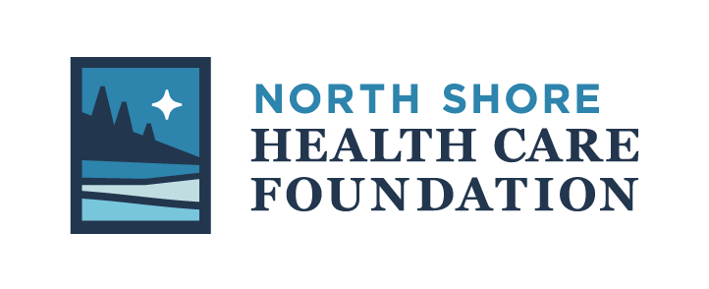
Grant Application

The North Shore Health Care Foundation (NSHCF) proactively identifies opportunities to expand equitable health care and healthy living in Cook County and champions solutions through funding, education, and advocacy. The NSHCF accepts grant applications twice per year through a Request for Proposals process. Submission deadlines are May 1 and October 1.

NSHCF currently awards grants for health, medical training and equipment for projects at the Sawtooth Mountain Clinic, North Shore Hospital, Cook County Public Health & Human Services, Higher Education, Fire Departments and EMS, the Oral Health Task Force and Care Partners (serving people needing palliative care as well as the elderly), and other initiatives that further the vision of “A healthy community for all in Cook County”.

The Foundation has identified three major priority areas to address critical needs in Cook County
in 2019 and beyond, including:

- Support for elders in the community
- Mental health and substance misuse needs in children, and
- Travel and lodging challenges for out-of-area health care needs

Priority may be given to projects that address these needs. Since 1995, NSHCF has awarded $1.1 million

Process
After each deadline, applications are reviewed by the Funds Distribution Committee. If applications are not complete or do not provide enough information, the applicant may be asked to provide additional information. The Funds Distribution Committee makes a recommendation to the Board and successful applicants will be notified and receive funding by July and December each year. The NSHCF will not fund organizations, initiatives, programs or events outside of Cook County, MN.

**Successful grantees must provide a report of how the funds were used to meet the intended goals within six months of the project completion. Images of the funded program may be requested and are preferred. **

APPLICATION
ORGANIZATIONAL INFORMATION
Date: _____________ Name of Organization:
Legal Name if Different (DBA):
Address:

City State Zip Code Employer Identification Number (EIN):

Phone Number Fax Website

Name of Lead Agency Official:

Title Phone Email

Contact Person Regarding this Application:

Title Phone Email

Is your organization an IRS 501(c)(3) not-for-profit? □ Yes □ No If so, please send a list of your Board of Directors

If no, is your organization a public entity/unit of government? □ Yes □ No

List of Board of Directors and Officers

____________________ President _______________________ Director
____________________ Vice-President _______________________ Director
____________________ Treasurer _______________________ Director
____________________ Secretary _______________________ Director
_______________________ Director _______________________ Director
_______________________ Director _______________________ Director
_______________________ Director _______________________ Director
_______________________ Director _______________________ Director
PROPOSAL INFORMATION
If your response does not fit the provided space, please attach a separate document.

- Title of project or program: __________________________________________________________
- Provide a brief explanation of what you are requesting funding for:

- Please provide a brief summary of the organization history, mission, goals and current programs:

- Please describe the opportunity, challenges, issues or need that your current proposal addresses:

- What are the specific activities that you are seeking funding for and who will carry out those activities?

- When will the activities take place? Provide a project time-line: _________________________________________________________________________________________________________________________________________________________________________________________________________________________________________________________
- How will the activities benefit the community?

- Does this initiative address any of the North Shore Health Care Foundation’s identified key priorities? If so, identify how in the space provided below:
- Support for elders in the community
- Mental health and substance misuse needs in children, and
- Travel and lodging challenges for out-of-area health care needs
- Healthcare workforce solutions
How, please explain:

- Does this initiative involve any collaboration with other agencies?
  - Yes
  - No
List other contributors/collaborators and roles ________________________________________________________________________
________________________________________________________________________
________________________________________________________________________
________________________________________________________________________
________________________________________________________________________
________________________________________________________________________
________________________________________________________________________
________________________________________________________________________
- How will you evaluate the success of the project?
BUDGET INFORMATION

- What is the dollar amount that is requested? $

- What is the total budget for the project? $

- Please provide a budget for the project which includes secured and anticipated income sources and a listing of all expenditures.

INCOME
Source: | Amount
 | $
 | $
 | $
 | $
 | $
Total Income: | $
EXPENSES
Source: | Amount
 | $
 | $
 | $
 | $
 | $
Total Budget: | $

Please provide the following items with your application:

- A copy of your current IRS determination letter indicating your tax-exempt 501(c)(3) status.

- Your most recent audit or Form 990.

- Organizational budget AND your most recent balance sheet.

Questions regarding grant applications and complete applications may be directed to:

Valerie Marasco Eliasen, Executive Director
North Shore Health Care Foundation
218-387-9076
NSHCF@boreal.org
www.NorthShoreHealthCareFoundation.org

