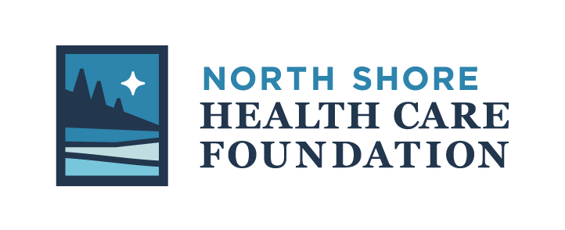
Grant Application

MISSION
The North Shore Health Care Foundation (NSHCF) proactively identifies opportunities to expand equitable health care and healthy living in Cook County and champions solutions through funding, education, and advocacy.

We believe in the possibilities of people, organizations, businesses and governments working together to create a healthy community for all in Cook County. We believe that health is not just the absence of illness. We believe a healthy community encompasses and is reflected in: the health of individuals which is embodied in prevention and education regarding health; in a community that maintains health through its systems of food, housing, employment, clean water, clean air, healthy exercise and social norms; and in access to quality, affordable health care for all.
For our part in creating a healthy Cook County we believe in proactively identifying opportunities that will expand equitable health care and healthy living. The basis for being proactive is consistently engaging with people and community leaders to understand the gaps and needs for creating a healthy community. We will operate in a manner that allows for nimbleness and flexibility in responding to emergent and critical needs. To do so means that we will monitor the outcomes of our work, consistently analyzing to determine if our work is creating a healthy community for all.
The NSHCF accepts grant applications twice per year through a Request for Proposals process. Submission deadlines are May 1 and October 1. Since 1995, NSHCF has awarded $1.16 million in grants.

NSHCF currently awards grants for initiatives that further the vision of “A healthy community for all in Cook County”. Covering gaps, enhancing health services, we want to support innovative programming that supports health and wellbeing?
The NSHCF has identified four major priority areas to address critical needs in Cook County since 2019, including:
- Support for elders in the community
- Mental health and substance misuse needs in children, and
- Travel and lodging challenges for out-of-area health care needs
- Healthcare workforce solutions

Priority may be given to projects that address these needs.

ELIGIBILITY
- All applications must align with the mission and vision of the Foundation.
- Applicants must be:
  - a qualified 501(c)(3) nonprofit organization,
  - a governmental organization, or
  - working in partnership with a qualified nonprofit fiscal agent.
- Applications from a single individual are ineligible for grant funding.
- The NSHCF will not fund organizations, initiatives, programs or events outside of Cook County, MN.

PROCESS
After each deadline, applications are reviewed by the Funds Distribution Committee. If applications are not complete or do not provide enough information, the applicant may be asked to provide additional information. The Funds Distribution Committee makes a recommendation to the Board and successful applicants will be notified and receive funding by July and December each year.

Successful grantees must provide a report of how the funds were used to meet the intended goals within six months of the project completion. Images of the funded program may be requested and are preferred.

DIVERSITY, EQUITY AND INCLUSION STATEMENT
The North Shore Health Care Foundation (NSHCF) strives to act inclusively in all that it does. The NSHCF recognizes the diversity of human differences, and values the inherent worth of all people. NSHCF does its work with compassion and inclusivity by creating healthy communities with partners and in the conduct of its business internally. The NSHCF recognizes that health and well-being are directly connected to honoring the truth and wholeness of each person. Toward that end it strives to respect and support diverse identities in the communities it serves. The NSHCF endeavors to be nimble and open to teachings from those communities so that it can serve as an ally and partner in creating greater equity and inclusion for all in Cook County. The NSHCF ask all partners and grantees to honor these values in our work together.

APPLICATION
ORGANIZATIONAL INFORMATION
Date: _____________ Name of Organization:
Legal Name if Different (DBA):
Address:

City State Zip Code Employer Identification Number (EIN):

Phone Number Fax Website

Name of Lead Agency Official:

Title Phone Email

Contact Person Regarding this Application:

Title Phone Email

Who will be responsible for the oversight of this project: __________________________________________________________________________

Is your organization an IRS 501(c)(3) not-for-profit? □ Yes □ No
(Provide list of your Board of Directors below)
If no, who is the qualified 501(c)(3) fiscal agent for this project ________________________________________________ Contact: __________________________

If no, is your organization a public entity/unit of government? □ Yes □ No

List of Board of Directors and Officers:
____________________ President _______________________ Director
____________________ Vice-President _______________________ Director
____________________ Treasurer _______________________ Director
____________________ Secretary _______________________ Director
_______________________ Director _______________________ Director

PROPOSAL INFORMATION
If your response does not fit the provided space, please attach a separate document.

- Title of project or program: __________________________________________________________
- Provide a brief explanation of what you are requesting funding for:
- Please provide a brief summary of the organization history, mission, goals and current programs:

- Please describe the opportunity, challenges, issues or need that your current proposal addresses:

- What are the specific activities that you are seeking funding for and who will carry out those activities?

- When will the activities take place? Provide a project time-line:
- How will the activities benefit the community?

- Does this initiative address any of the North Shore Health Care Foundation’s identified key priorities? If so, identify how in the space provided below:
- Support for elders in the community
- Mental health and substance misuse needs in children, and
- Travel and lodging challenges for out-of-area health care needs
- Healthcare workforce solutions
How, please explain:

- Does this initiative involve any collaboration with other agencies?
  - Yes
  - No
List other contributors/collaborators and roles ________________________________________________________________________
________________________________________________________________________
________________________________________________________________________
________________________________________________________________________
________________________________________________________________________
________________________________________________________________________
________________________________________________________________________
________________________________________________________________________
- How will you evaluate the success of the project?

- How does the project include or address diversity, equity and/or inclusion?
BUDGET INFORMATION

- What is the dollar amount that is requested? $

- What is the total budget for the project? $

- Please provide a budget for the project which includes secured and anticipated income sources and a listing of all expenditures.

INCOME
Source: | Amount
 | $
 | $
 | $
 | $
 | $
Total Income: | $
EXPENSES
Source: | Amount
 | $
 | $
 | $
 | $
 | $
Total Budget: | $

Please provide the following items with your application:

- A copy of your current IRS determination letter indicating your tax-exempt 501(c)(3) status.
- Your most recent audit or Form 990.
- Agreement of Fiscal Agency {If not a nonprofit 501(c)(3)}

- Organizational budget AND your most recent balance sheet.

Questions regarding grant applications and complete applications may be directed to:
Valerie Marasco Eliasen, Executive Director
North Shore Health Care Foundation
218-387-9076
NSHCF@boreal.org
www.NorthShoreHealthCareFoundation.org

